Lab # 9
Exploring Numpy and Pandas Library

OBJECTIVE
Exploring various functions of Numpy and Pandas library.

THEORY

NumPy, which stands for Numerical Python, is a library consisting of multidimensional array objects and a collection of routines for processing those arrays. Using NumPy, mathematical and logical operations on arrays can be performed.

Operations using NumPy:

Using NumPy, a developer can perform the following operations −

- Mathematical and logical operations on arrays.
- Fourier transforms and routines for shape manipulation.
- Operations related to linear algebra. NumPy has in-built functions for linear algebra and random number generation.
NumPy Arrays:
A numpy array is a grid of values, all of the same type, and is indexed by a tuple of nonnegative integers. The number of dimensions is the rank of the array; the shape of an array is a tuple of integers giving the size of the array along each dimension.
We can initialize numpy arrays from nested Python lists, and access elements using square brackets:
import numpy as np

- = np.array([1, 2, 3]) # Create a rank 1 array
print(type(a)) # Prints "<class 'numpy.ndarray'>" print(a.shape) # Prints "(3,)" print(a[0], a[1], a[2]) # Prints "1 2 3"
a[0] = 5 # Change an element of the array print(a) # Prints "[5, 2, 3]"

b = np.array([[1,2,3],[4,5,6]]) # Create a rank 2 array
print(b.shape) # Prints "(2, 3)" print(b[0, 0], b[0, 1], b[1, 0]) # Prints "1 2 4"
Numpy also provides many functions to create arrays:
import numpy as np

- = np.zeros((2,2)) # Create an array of all zeros
print(a) # Prints "[[ 0. 0.] # [ 0. 0.]]"

b = np.ones((1,2)) # Create an array of all ones print(b) # Prints "[[ 1. 1.]]"

c = np.full((2,2), 7) # Create a constant array print(c) # Prints "[[ 7. 7.], [7. 7.]]"

d = np.eye(2) # Create a 2x2 identity matrix
print(d) # Prints "[[ 1. 0.] # [0. 1.]]"

e = np.random.random((2,2)) # Create an array filled with random values print(e) # Might print "[[ 0.91940167 0.08143941]
# [ 0.68744134 0.87236687]]"
Array indexing
Numpy offers several ways to index into arrays.

Slicing: Similar to Python lists, numpy arrays can be sliced. Since arrays may be multidimensional, you must specify a slice for each dimension of the array:
import numpy as np

# Create the following rank 2 array with shape (3, 4)
# [[ 1 2 3 4]
# [ 5 6 7 8] # [ 9 10 11 12]]
- = np.array([[1,2,3,4], [5,6,7,8], [9,10,11,12]])

# Use slicing to pull out the subarray consisting of the first 2 rows # and columns 1 and 2; b is the following array of shape (2, 2): # [[2 3] # [6 7]]
b = a[:2, 1:3]

# A slice of an array is a view into the same data, so modifying it
# will modify the original array.
print(a[0, 1]) # Prints "2"
b[0, 0] = 77 # b[0, 0] is the same piece of data as a[0, 1] print(a[0, 1]) # Prints "77"
Array math
Basic mathematical functions operate elementwise on arrays, and are available both as operator overloads and as functions in the numpy module:
import numpy as np

x = np.array([[1,2],[3,4]], dtype=np.float64) y = np.array([[5,6],[7,8]], dtype=np.float64)

print(x + y) print(np.add(x, y))

print(x - y)
print(np.subtract(x, y))

print(x * y)
print(np.multiply(x, y))

print(x / y)
print(np.divide(x, y))

print(np.sqrt(x))
Random Distribution
A random distribution is a set of random numbers that follow a certain probability density function.

Probability Density Function: A function that describes a continuous probability. i.e. probability of all values in an array.

We can generate random numbers based on defined probabilities using the choice() method of the random module.

The choice() method allows us to specify the probability for each value.

The probability is set by a number between 0 and 1, where 0 means that the value will never occur and 1 means that the value will always occur.
Example:
from numpy import random

x = random.choice([3, 5, 7, 9], p=[0.1, 0.3, 0.6, 0.0], size=(100))

print(x)

OUTPUT:

[5 5 5 3 5 7 5 7 7 5 7 7 7 5 5 5 5 7 7 7 7 5 3 7 7 3 7 7 5 7 7 7 7 3 5 7 7 7 7 7 5 7 7 3 5 7 7 5 7 3 7 7 5 7 7 5 7 5 5 7 5 5 7 5 5 7 3 7 7 5 7 7 5 5 5 5 7 5 5 7 7 7 7 5 7 5 7 7 5 5 7 5 7 5 7 7 7 7 3 7]

PANDAS LIBRARY:
Pandas is a software library written for the Python programming language for data manipulation and analysis. In particular, it offers data structures and operations for manipulating numerical tables and time series.
WHAT IS A DATAFRAME?
A Pandas DataFrame is a 2 dimensional data structure, like a 2 dimensional array, or a table with rows and columns.
EXAMPLE:
Import pandas as pd
data = {
"calories": [420, 380, 390],
"duration": [50, 40, 45] }
#load data into a DataFrame object: df = pd.DataFrame(data) print(df)
OUTPUT:
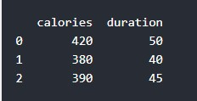

LOCATE ROW
Pandas use the loc attribute to return one or more specified row(s).
EXAMPLE:
#refer to the row index:
print(df.loc[0])
Return row 0 and 1:
#use a list of indexes: print(df.loc[[0, 1]])

NAMED INDEXES
With the index argument, you can name your own indexes.
Example:
import pandas as pd

data = {
"calories": [420, 380, 390],
"duration": [50, 40, 45]
}

df = pd.DataFrame(data, index = ["day1", "day2", "day3"])

print(df)

LOCATE NAMED INDEXES
Use the named index in the loc attribute to return the specified row(s).
EXAMPLE:
#refer to the named index: print(df.loc["day2"])
OUTPUT:

calories 380

duration 40

Name: 0, dtype: int64

PANDAS ANALYZING DATAFRAME:

VIEWING THE DATA
One of the most used method for getting a quick overview of the DataFrame, is the head() method.
The head() method returns the headers and a specified number of rows, starting from the top.
import pandas as pd

df = pd.read_csv('data.csv')

print(df.head(10))
There is also a tail() method for viewing the last rows of the DataFrame.
The tail() method returns the headers and a specified number of rows, starting from the bottom.

INFO ABOUT THE DATA
The DataFrames object has a method called info(), that gives you more information about the data set.
EXAMPLE:
print(df.info())
OUTPUT:
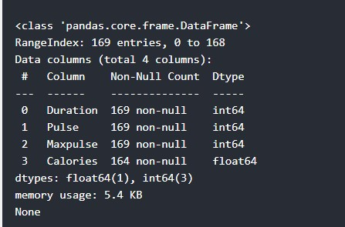 None

PANDAS - CLEANING DATA
Data cleaning means fixing bad data in your data set.
Bad data could be:
- Empty cells
- Data in wrong format
- Wrong data
- Duplicates
Empty Cells
Empty cells can potentially give you a wrong result when you analyze data.

Remove Rows
One way to deal with empty cells is to remove rows that contain empty cells.
This is usually OK, since data sets can be very big, and removing a few rows will not have a big impact on the result.
EXAMPLE:
import pandas as pd

df = pd.read_csv('data.csv')

new_df = df.dropna()

print(new_df.to_string())

EXAMPLE
Remove all rows with NULL values:
import pandas as pd

df = pd.read_csv('data.csv')

df.dropna(inplace = True)

print(df.to_string())

Replace Empty Values
Another way of dealing with empty cells is to insert a new value instead.
This way you do not have to delete entire rows just because of some empty cells.
The fillna() method allows us to replace empty cells with a value:

EXAMPLE
Replace NULL values with the number 130:
import pandas as pd

df = pd.read_csv('data.csv')

df.fillna(130, inplace = True)
Replace Only For a Specified Columns
The example above replaces all empty cells in the whole Data Frame.
To only replace empty values for one column, specify the column name for the DataFrame:

EXAMPLE
Replace NULL values in the "Calories" columns with the number 130:
import pandas as pd

df = pd.read_csv('data.csv')

df["Calories"].fillna(130, inplace = True) Replace Using Mean, Median, or Mode
A common way to replace empty cells, is to calculate the mean, median or mode value of the column.
Pandas uses the mean() median() and mode() methods to calculate the respective values for a specified column:
Example
Calculate the MEAN, and replace any empty values with it:
import pandas as pd

df = pd.read_csv('data.csv')

x = df["Calories"].mean()

df["Calories"].fillna(x, inplace = True) Removing Duplicates
To remove duplicates, use the drop_duplicates() method.

EXAMPLE
Remove all duplicates:
df.drop_duplicates(inplace = True)

PLOTTING
Pandas uses the plot() method to create diagrams.
Pythons uses Pyplot, a submodule of the Matplotlib library to visualize the diagram on the screen.
Example
Import pyplot from Matplotlib and visualize our DataFrame:
import pandas as pd import matplotlib.pyplot as plt

df = pd.read_csv('data.csv')

df.plot()

plt.show()

SCATTER PLOT
Specify that you want a scatter plot with the kind argument:
kind = 'scatter'
A scatter plot needs an x- and a y-axis.
In the example below we will use "Duration" for the x-axis and "Calories" for the y-axis.
Include the x and y arguments like this:
x = 'Duration', y = 'Calories'
Example import pandas as pd
import matplotlib.pyplot as plt

df = pd.read_csv('data.csv')

df.plot(kind = 'scatter', x = 'Duration', y = 'Calories')

plt.show()
Result
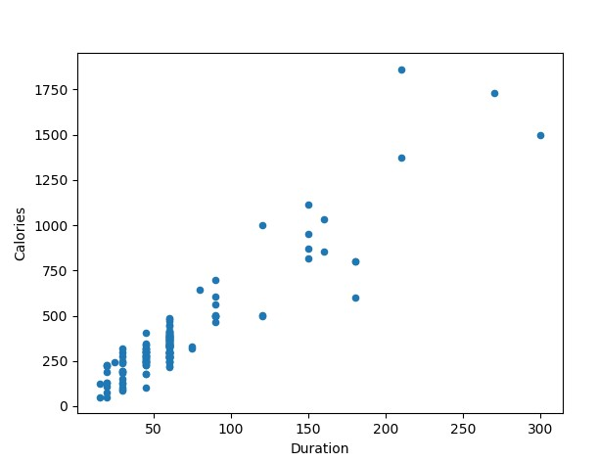

HISTOGRAM
Use the kind argument to specify that you want a histogram:
kind = 'hist'
A histogram needs only one column.
A histogram shows us the frequency of each interval, e.g. how many workouts lasted between 50 and 60 minutes?
In the example below we will use the "Duration" column to create the histogram:
Example
df["Duration"].plot(kind = 'hist')

Result
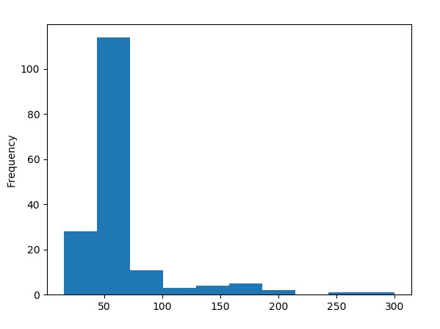

Lab Tasks:
- Perform all the given functions of Numpy and Pandas then show the output.
- Import your excel file and perform any ten functions of Numpy and Pandas.

